**Topics: Descriptive Statistics and Probability**

1. Look at the data given below. Plot the data, find the outliers and find out $μ, σ, σ^{2}$

|  |  |
| --- | --- |
| **Name of company** | **Measure X** |
| Allied Signal | 24.23% |
| Bankers Trust | 25.53% |
| General Mills | 25.41% |
| ITT Industries | 24.14% |
| J.P.Morgan & Co. | 29.62% |
| Lehman Brothers | 28.25% |
| Marriott | 25.81% |
| MCI | 24.39% |
| Merrill Lynch | 40.26% |
| Microsoft | 32.95% |
| Morgan Stanley | 91.36% |
| Sun Microsystems | 25.99% |
| Travelers | 39.42% |
| US Airways | 26.71% |
| Warner-Lambert | 35.00% |

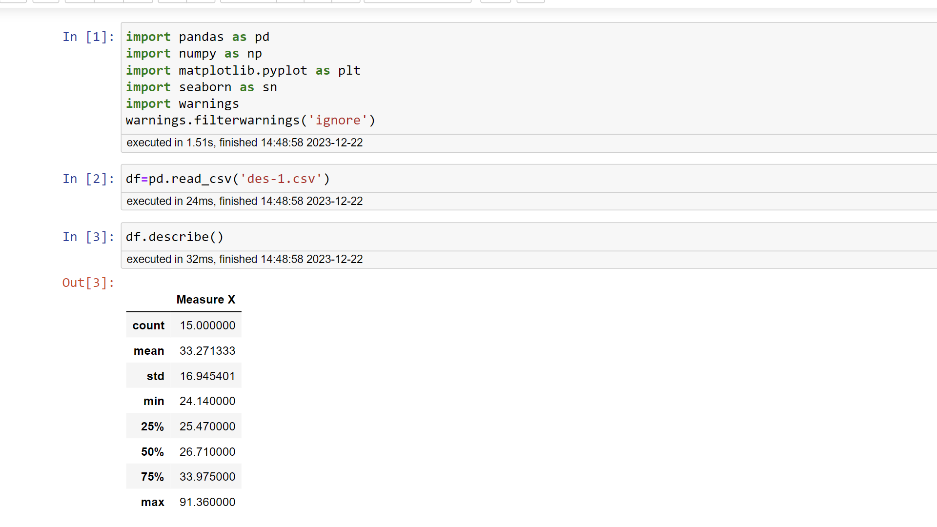

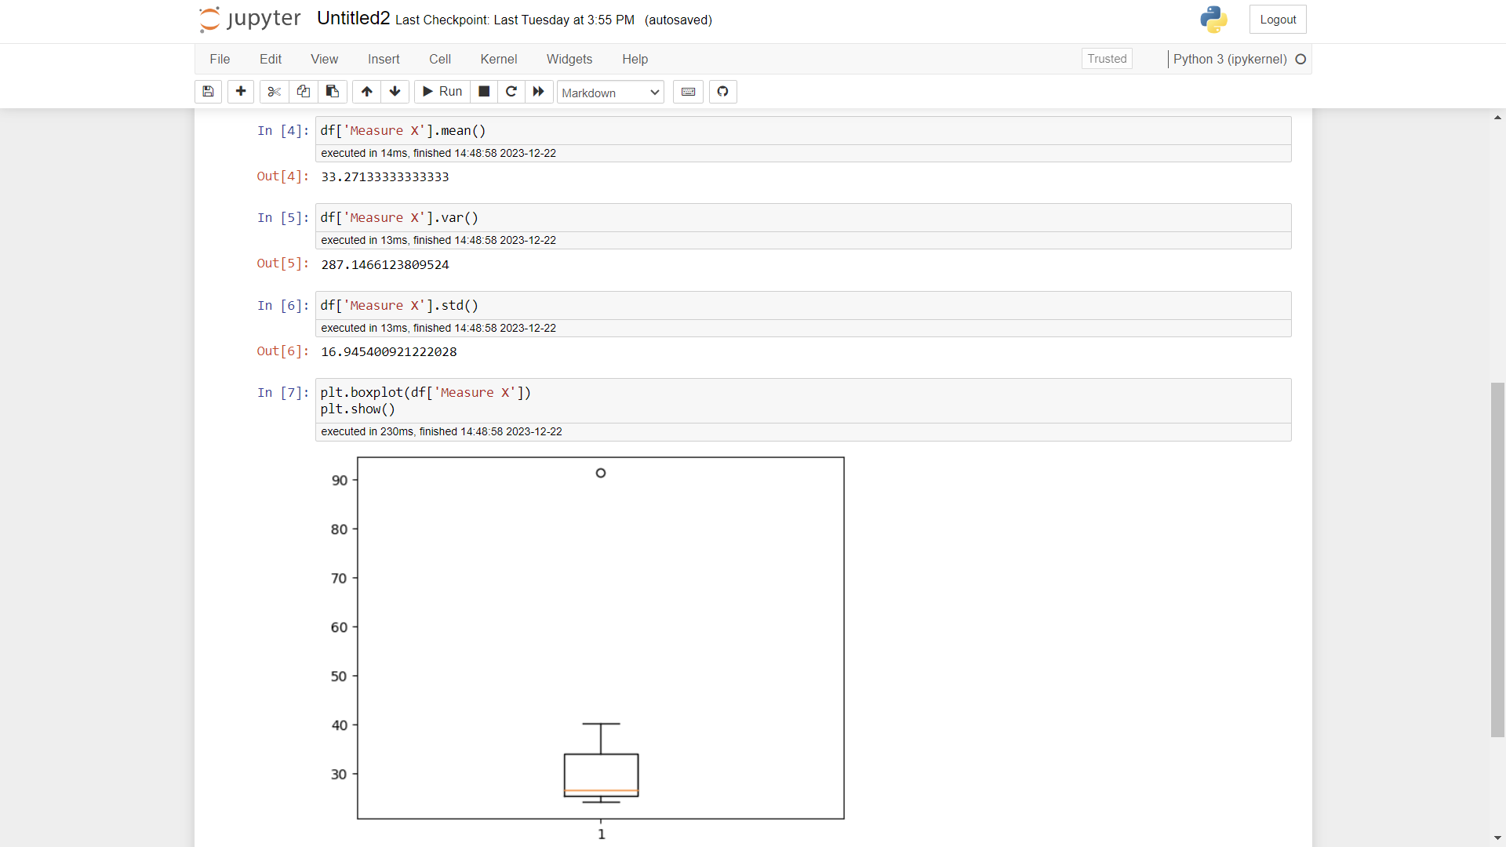

Therefore, the outlier is 91.36



Answer the following three questions based on the box-plot above.

1. What is inter-quartile range of this dataset? (please approximate the numbers) In one line, explain what this value implies.

IQR=Q3-Q1=12-5=7

1. What can we say about the skewness of this dataset?

The data is right skewed and has positive skewness.

1. If it was found that the data point with the value 25 is actually 2.5, how would the new box-plot be affected?

In that case there wouldn’t be any outliers and the data will be normally distributed.



3.

Answer the following three questions based on the histogram above.

1. Where would the mode of this dataset lie?

The mode would lie in between 5 and 10

1. Comment on the skewness of the dataset.

The data right skewed and has positive skewness

1. Suppose that the above histogram and the box-plot in question 2 are plotted for the same dataset. Explain how these graphs complement each other in providing information about any dataset.

Both the graphs complement each other by providing the data about the outliers and the visualization of mean and mode along with the skewness.

1. AT&T was running commercials in 1990 aimed at luring back customers who had switched to one of the other long-distance phone service providers. One such commercial shows a businessman trying to reach Phoenix and mistakenly getting Fiji, where a half-naked native on a beach responds incomprehensibly in Polynesian. When asked about this advertisement, AT&T admitted that the portrayed incident did not actually take place but added that this was an enactment of something that “could happen.” Suppose that one in 200 long-distance telephone calls is misdirected. What is the probability that at least one in five attempted telephone calls reaches the wrong number? (Assume independence of attempts.)

The probability of call redirection (p) = 1/200

The probability of call not redirecting (q) = 1-(1/200) = 199/200

n=5

r=1

P (at least 1 in 5 calls redirect) = nCr *pr*qn-r = 5C1 * (1/200)1 * (199/200)5-1

= 5 * 1/200 * (199/200)4 = 5 * 0.005 * 0.98 = 0.0245

1. Returns on a certain business venture, to the nearest $1,000, are known to follow the following probability distribution

|  |  |
| --- | --- |
| x | P(x) |
| -2,000 | 0.1 |
| -1,000 | 0.1 |
| 0 | 0.2 |
| 1000 | 0.2 |
| 2000 | 0.3 |
| 3000 | 0.1 |

1. What is the most likely monetary outcome of the business venture?

2000, as it has the highest probability.

1. Is the venture likely to be successful? Explain.

Yes, the venture has the probability of 80% of success. Because,

P (0) + P (1000) + P (2000) + P (3000) = 0.2 + 0.2 + 0.3 + 0.1 = 0.8

1. What is the long-term average earning of business ventures of this kind? Explain.

Average(µ) = Sum (xi * Pi) = (-2000*0.1) + (-1000*0.1) + (0*0.2) +

(1000*0.2) + (2000*0.3) + (3000*0.1) = 800

This indicates that the average earning of the venture is $800

1. What is the good measure of the risk involved in a venture of this kind? Compute this measure.

We can say that variance is the good measure of risk, which explains the variability of distribution of the data. As variance value increases, the chance of risk increases.

Variance can be calculated as (1/n) * (∑ (xi - µ)2)

Variance = (1/6) * ((-2000-800)2 + (-1000-800)2+(0-800)2 + (1000-800)2+(2000-800)2+(3000-800)2) = 18040000/6 ≈ 3006667